Web Engineering Project

**1st Phase – Static Version of Website**

Project Requirements

1. Project have five pages (HTML/CSS Version Responsive Layout)
   1. Home
   2. About Us
   3. Products
   4. Products Details
   5. Contact Us

Layout required as follows (Strictly follow the layout)

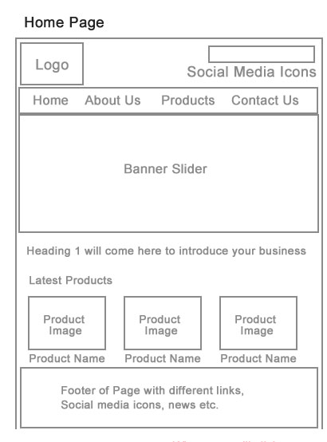

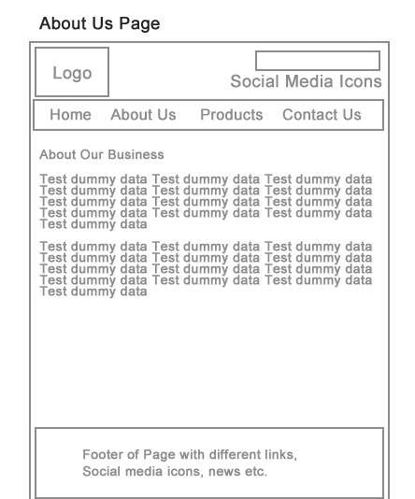

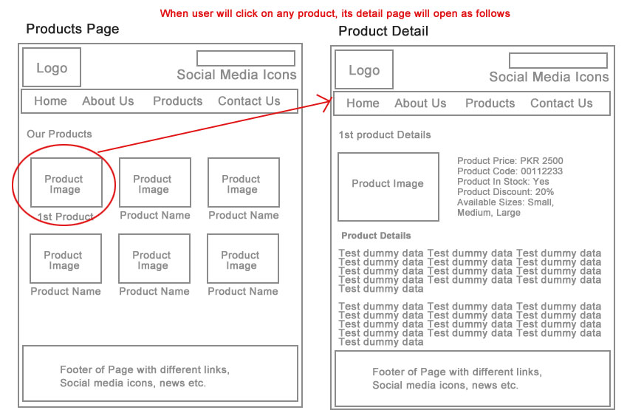

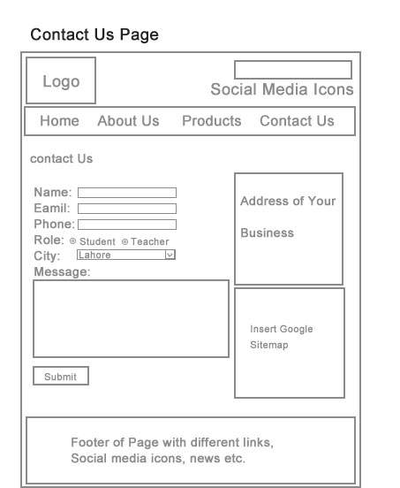

**Note:**

1. Use Java script to move from one page to another. For e.g. If user wants to visit About us page from home, then after clicking to About us tab without anchor tag, he should be able to view About us page.
2. First phase should be made completely mobile responsive by using bootstrap grid system, except product detail page should be made responsive using media queries (for at least 11 mobile devices).
3. Add form validation in Contact Us Form. Such as Name should contain both characters only and email should contain @ and it cannot be less than 9 characters, phone number should be more than 10 characters and should contain +92, Role should be checked before form submission. (Error Messages should be displayed in bootstrap alert divs).
4. Project should be configured by using latest version of Bootstrap (Any version greater or equal to 4.0)
5. Attach a file named as first.html, containing names and roll number of group members in <p> tag.
6. Maximum three group members are allowed.